Disaster Management System
By Remotz Systems

Deliverable-3

Project Team

Muhammad Moiz Ansari 23i-0523
Zohaib Umer 23i-0528
Rehan Tajik 23i-0730
Muhammad Tayyab 23i-0738

Semester 6

Supervised by
Ms. Rabail Zahid



Department of Computer Science National University of Computer and Emerging Sciences Islamabad, Pakistan
April 19th, 2026

PART C - Deliverable 3 Document
1. Introduction
The Disaster Management System (DMS) is a desktop-based Java application developed to streamline the coordination, communication, and resource management required during natural disasters such as floods, earthquakes, and fires in Pakistan. The system serves four user roles — Admin, Rescue Team, NGO, and Citizen — each with a dedicated dashboard and role-specific functionality.

Sprint 1 established the foundational layer of the system: user registration and authentication, disaster record management, disaster alert broadcasting, and citizen disaster reporting.

Sprint 2 extended the system with a centralized resource inventory, dynamic resource allocation to response teams and NGOs, field resource request capabilities, and a citizen emergency SOS feature.

With Sprint 3, the system has reached full operational completion. The final sprint implements the entire response coordination loop: assigning NGOs and rescue teams to disasters, tracking deployed team locations and mission timelines, enabling field teams to update their mission status in real time, generating comprehensive disaster reports, and capturing post-operation feedback. Together, the three sprints deliver a complete, integrated Disaster Management System ready for operational use.
2. Project Vision
To create a centralized, resilient platform that empowers communities and response organizations to collaborate effectively during disasters, ultimately saving lives and reducing property damage through timely information and organized action.

With the completion of Sprint 3, this vision is fully realized. The DMS now covers the entire disaster lifecycle — from initial citizen reporting through coordinated response, real-time tracking, post-operation reporting, and performance feedback. The system ensures that no disaster goes unaddressed due to communication failures, resource misallocation, or lack of coordination between response entities.
3. Intended Use of the System
Stakeholders and Updated Needs
Stakeholder | Updated Needs — Sprint 3
Citizens | Need to report disasters, request emergency help, view active alerts, and provide post-operation feedback on response quality.
NGOs | Need to view disaster assignments, manage relief distribution, update mission status, request additional resources, and submit performance feedback.
Rescue Teams | Need to receive mission assignments, update their deployment status in real time (En Route → On Site → Completed), track resources allocated to them, and submit post-mission feedback.
Admin | Needs full control of disaster lifecycle management: record creation, alert broadcasting, NGO/team assignment, resource allocation, team tracking, report generation, and feedback review.
Government Agencies | Need access to generated disaster reports (PDF/Excel/CSV) for policy decisions, budget planning, and operational accountability.

4. Features / Overall Functionality
Completed in Sprint 1 - User Authentication & Disaster Reporting
- Secure role-based User Authentication and Registration (Admin, Citizen, NGO, Rescue Team).
- Citizen-driven Disaster Reporting and Admin-driven Disaster Record Management (CRUD).
- Real-time Alert Broadcasting to all registered stakeholders.
- Citizen alert viewing dashboard.

Completed in Sprint 2 - Resource Management & Emergency Response
- Centralized Resource Inventory: Admins can add, edit, delete, and track master supplies.
- Dynamic Resource Allocation: Admins assign specific quantities of resources to NGOs and rescue teams.
- Field Resource Requests: NGOs and Rescue Teams can view allocations and request further assistance.
- Emergency SOS: A dedicated high-priority emergency trigger for citizens in immediate danger.

Completed in Sprint 3 - Coordination, Monitoring & System Completion
- NGO Assignment: Admin assigns available NGOs to active disasters; NGO notified automatically.
- Rescue Team Assignment: Admin assigns available teams; Mission record created automatically.
- Real-Time Team Tracking: Admin monitors deployed team locations on a Pakistan map with status timelines.
- Mission Status Management: Rescue Teams and NGOs update mission status (Assigned → En Route → On Site → Completed).
- Disaster Report Generation: Admin generates filterable reports and exports to PDF, Excel, or CSV.
- Feedback System: Citizens, NGOs, and Rescue Teams submit rated feedback; Admin reviews and resolves.

How Sprint 3 Completes System Capability
Sprint 3 closes the disaster response loop that Sprints 1 and 2 initiated. Without Sprint 3, the system could detect and respond to a disaster, but had no mechanism to formally deploy response entities, monitor their progress, or evaluate the quality of the response. The addition of the NGO/Team assignment creates the formal deployment chain. Track Rescue Team provides the Admin with operational visibility. Update Mission Status gives field teams a voice in the system. Generate Report transforms raw data into actionable intelligence. Give/Review Feedback creates a continuous improvement mechanism. Together, these features elevate the DMS from a data entry tool to a fully operational disaster coordination platform.

5. User Stories - Sprint 3 Summary
The following user stories were implemented in Sprint 3. Full backlog tables are provided in Part B, Section 2.

• Assign NGO
  - US-19: Assign NGO (Admin)
  - US-20: View Available NGOs (Admin)
• Assign Rescue Team
  - US-22: Assign Rescue Team (Admin)
  - US-23: View Available Rescue Teams (Admin)
  - US-24: Assign Team to Disaster (Admin)
• Track Rescue Team
  - US-25: Track Rescue Team (Admin)
  - US-26: View Active Teams Dashboard (Admin)
  - US-27: View Team Location & Status (Admin)
• Update Mission Status
  - US-28: Update Mission Status (NGO, Rescue Team)
  - US-29: Mark Mission In Progress (NGO, Rescue Team)
  - US-30: Mark Mission Completed (NGO, Rescue Team)
• Generate Disaster Report
  - US-31: Generate Disaster Report (Admin)
  - US-32: Set Report Parameters (Admin)
  - US-33: Export/Download Report (Admin)
• Feedback
  - US-34: Give Feedback (Citizen, NGO, Rescue Team)
  - US-35: Review Feedback (Admin)

6. Non-Functional Requirements (NFR) - Updated for Sprint 3
NFR ID | Category | Natural Language Specification
NFR-01 | Performance | The system shall load the Admin Dashboard within 3 seconds under normal database conditions with up to 1,000 records across all tables.
NFR-02 | Performance | Alert broadcast to all registered stakeholders shall be completed within 5 seconds of Admin confirmation.
NFR-03 | Availability | The system shall be available 99.5% of the time during operational hours to ensure citizens can report disasters at any time.
NFR-04 | Security | Only users with the Admin role shall have access to the Manage Disaster Records, Broadcast Alert, Assign NGO, Assign Rescue Team, and Generate Report modules.
NFR-05 | Security | All user passwords shall be stored in the database using irreversible hashing; plaintext passwords shall never be stored or transmitted.
NFR-06 | Usability | The Report Disaster form shall be navigable and submittable within 3 user interactions to ensure ease of use during emergencies.
NFR-07 | Usability | New users shall be able to complete their primary task (report a disaster, submit feedback, update mission status) within 5 minutes without prior training.
NFR-08 | Scalability | The system shall support at least 5,000 concurrent users accessing different dashboards without performance degradation.
NFR-09 | Scalability | The Report Generation module shall handle datasets of up to 10,000 disaster records without exceeding a 15-second generation time.
NFR-10 | Reliability | The system shall handle all invalid user inputs gracefully, displaying appropriate error messages without crashing or corrupting data.
NFR-11 | Data Integrity | All assignment operations (NGO/Rescue Team) shall be performed within database transactions; partial failures shall trigger automatic rollback.
NFR-12 | Maintainability | The system shall follow a layered architecture (Controller → Service → DAO), ensuring each layer is independently testable and modifiable.

7. Testing and Quality Assurance Summary
Full testing artifacts are provided in Part B, Section 6. The following summarizes the testing approach and results for Sprint 3.

- Test Plan: Covers all 6 Sprint 3 modules with defined objectives, entry/exit criteria, and test types (functional, black-box, white-box, regression).
- Black-Box Testing: 18 test cases designed using Equivalence Partitioning, Boundary Value Analysis, and Error Guessing. All 18 passed.
- White-Box Testing: Statement, branch, and condition coverage applied to 3 critical methods — performAssignment(), validateForm(), and updatePreview(). 100% coverage achieved on all three.
- Bug Report: 5 bugs identified and resolved — including a critical Mission ID duplication bug and a NullPointerException in the map tracking module.
- Quality Impact: Testing improved system reliability, prevented data integrity failures, eliminated runtime crashes, and validated all user-facing validation messages.

8. Iteration 3 - Implementation Screenshots
8.1 Assign NGO Page
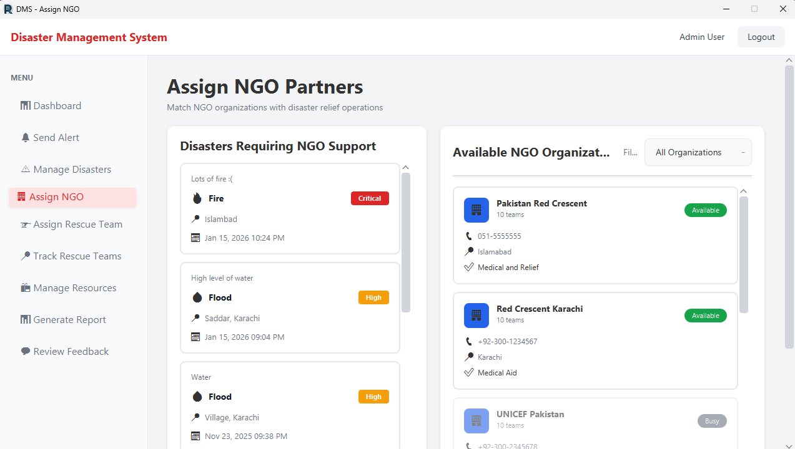

8.2 Assign Rescue Team Page
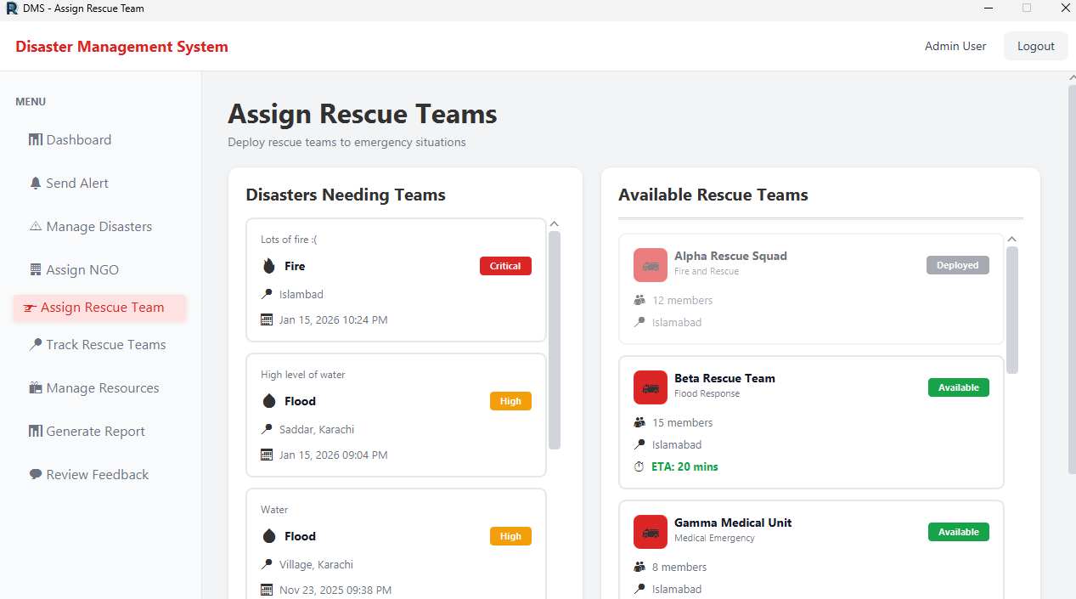

8.3 Track Rescue Teams Page
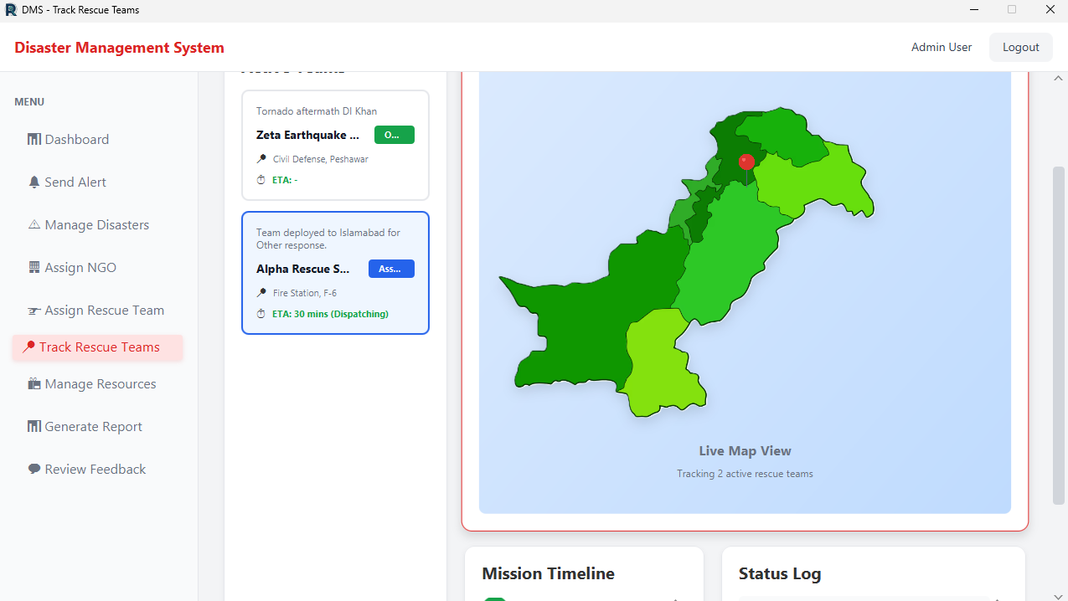

8.4 Update Mission Status (Rescue Team Dashboard)
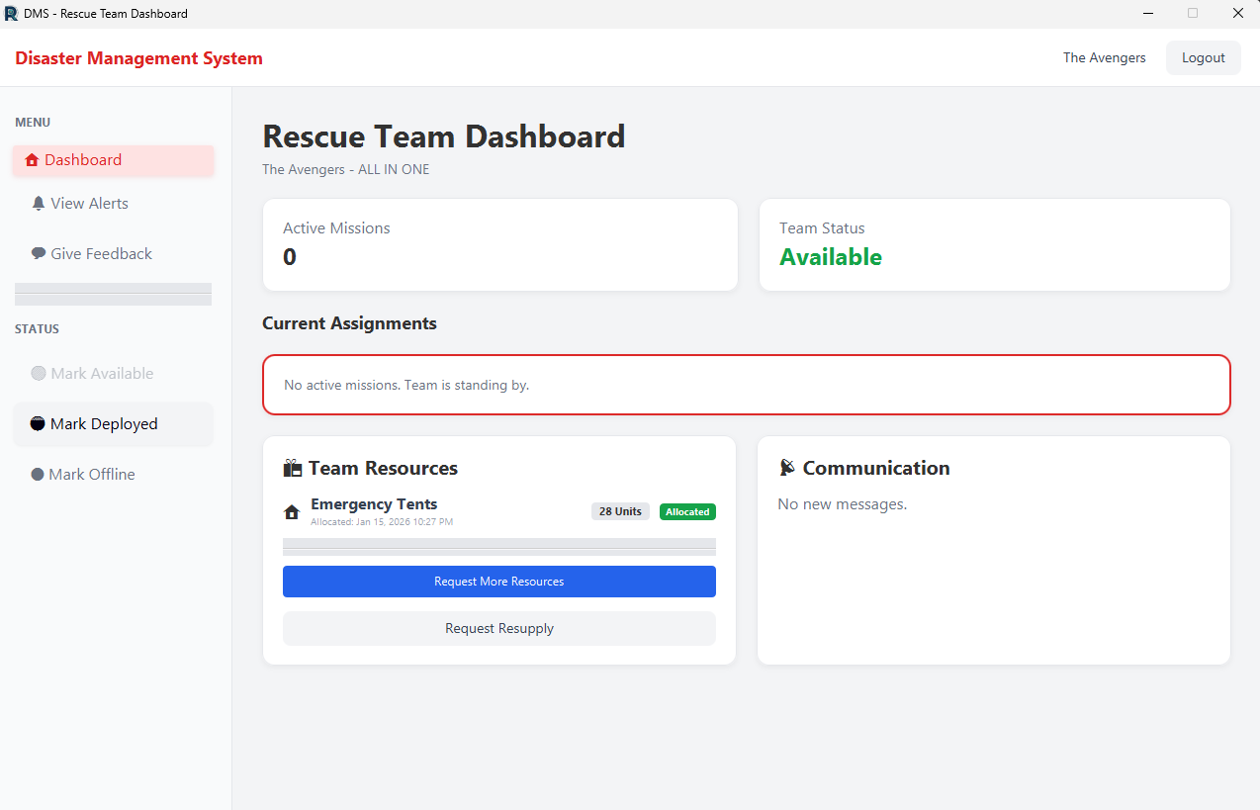

8.5 Generate Report Page
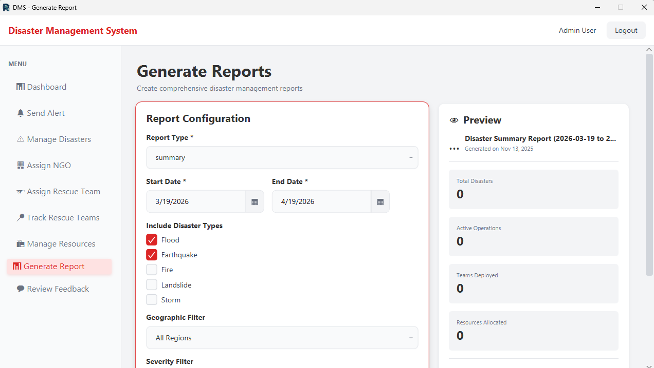

8.6 Give Feedback Page
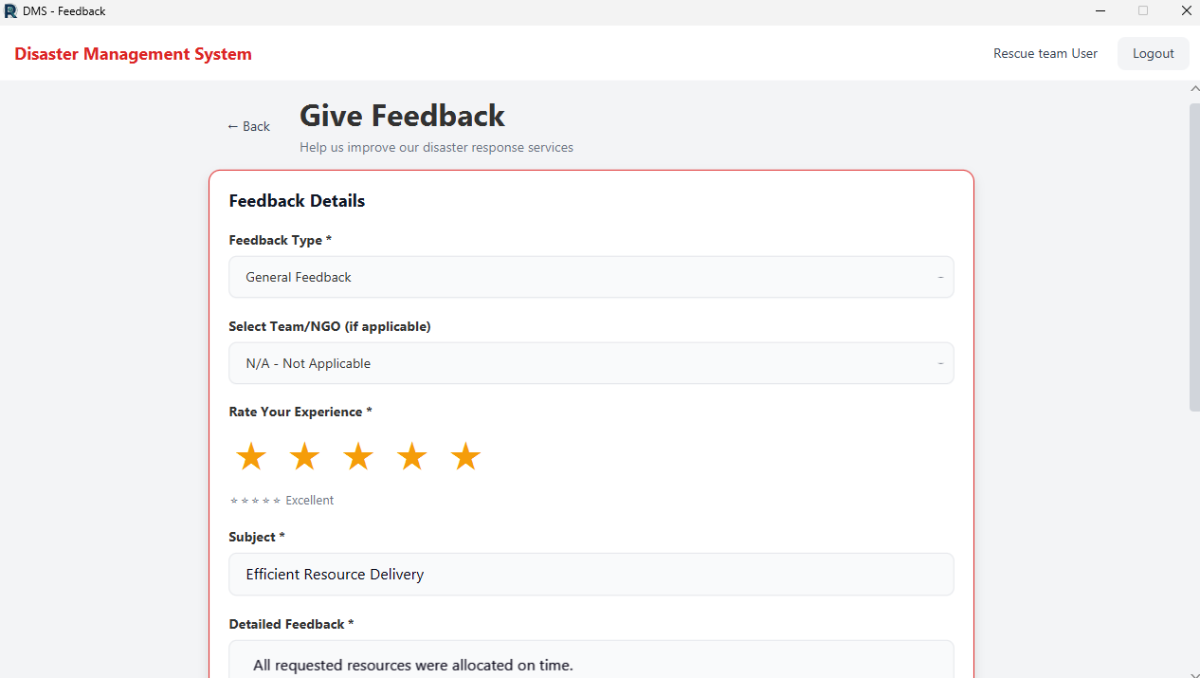

8.7 Review Feedback Page (Admin)
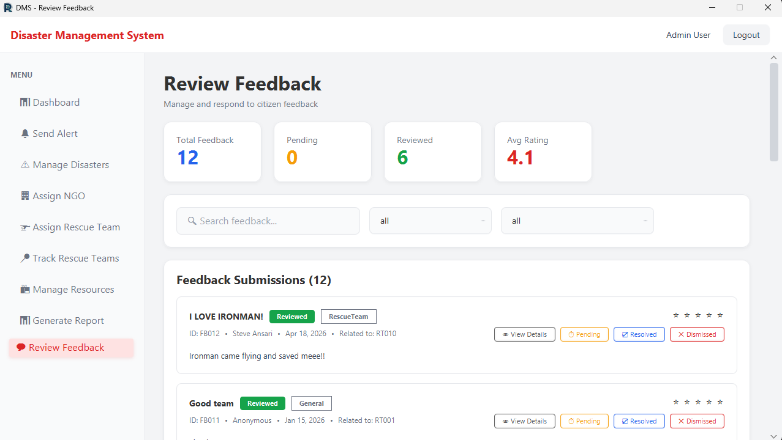

9. Work Division for Sprint 3
Team Member | Tasks / Responsibilities | Deliverable Contribution
Muhammad Moiz Ansari (Team Lead / Scrum Master) | Assigned tasks across the team.  Developed Assign NGO & Assign Rescue Team modules (US-19–US-24).  Developed Track Rescue Teams with map integration (US-25–US-27).  Updated all deliverable documents. | Part B (Sprint Overview, User Stories, Scrum Board setup), Section 5 (Tests)  Part C (Screenshots attached)  Code final fixes, database
Rehan Tajik | Developed the Update Mission Status module (US-28–US-30).  Integrated mission timeline and status log in Track Teams view.  Performed black-box testing for Track & Mission modules. | Part B Section 3 (US-19 – US-22)  Part C
Zohaib Umer | Developed the Generate Disaster Report module (US-31–US-33).  Implemented PDF/Excel/CSV export using iText and Apache POI.  Performed black-box testing for the Report module. | Part B Section 3 (US-23 – US-30)
Muhammad Tayyab | Developed Give Feedback & Review Feedback modules (US-34, US-35).  Wrote all 4 structured specifications.  Prepared test plan and bug report table. | Part B Section 3 (Specs 1-4, US-31 – US-35)

